**Key take-aways**

1. The market will support Big Mountain increasing our ticket price by up to $14.87, to a total of $95.87 per adult weekend ticket, with our currently available facilities.
2. There is support for either reducing the number of runs available or increasing runs, lifts, and our vertical drop – both scenarios rely on incorporating operation costs before they can be fully evaluated.

We were given the task of creating a model that will predict ticket prices based on facilities at ski resorts across the country for the purpose of evaluating Big Mountain’s ticket prices and facilities. From this model, we discovered a handful of key facilities that have a relatively large effect on ticket prices compared with other facilities. Shown below are the 5 most important features as identified by the model.

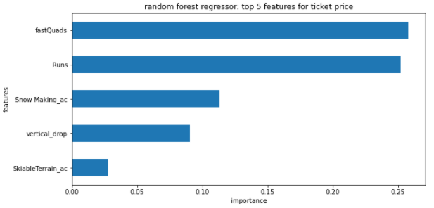

Business leadership shortlisted a set of 4 scenarios involving changing available facilities and features. Starting with the assumptions of 350,000 visitors a season, and each visitor staying an average of 5 day at the resort, we evaluated each of these scenarios using the model we created.

**Scenario 1: Permanently closing down up to 10 of the least used runs without affecting any other feature or facility at the resort.**

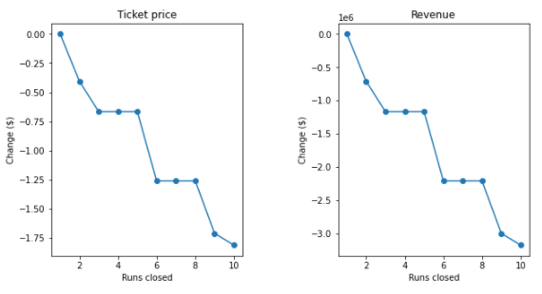

Shown here are two plots showing supported decreases in ticket price (left) and revenue (right) based on number of runs closed. Closing 1 run makes no difference in what we can charge for tickets, but would presumably reducing operating costs (which are not accounted for here) by a small amount. However, reducing the number of runs by 5 would result in a roughly 70 cent per ticket decrease while potentially saving much more than that in operating costs.

**Scenario 2: Increase the vertical drop by adding a run to a point 150 feet lower down but requiring the installation of an additional chair lift to bring skiers back up, without additional snow making coverage.**

Our model supports a ticket price increase of $1.99, giving us an estimated season revenue of $3,474,638 (again, discounting operation costs).

**Scenario 3: Same as number 2, but adding 2 acres of snow making cover.**

Scenario 3 does not support a ticket price increase above what is shown by scenario 2. While area covered by snow making is one of the top 4 features, Big Mountain already has more area coverage than most of the top resorts in the nation (shown as a red line in the distribution below).

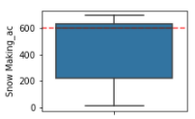

**Scenario 4: Increase the longest run by 0.2 mile to boast 3.5 miles length, requiring an additional snow making coverage of 4 acres.**

The small additions to skiable terrain and run length do not support an increase in ticket price. The model shows that these features are not considered as valuable as other features by customers. And the data shows that Big Mountain is already a leader in these features, so a small increase does not have the same effect here.

**Summary**

As things currently stand, Big Mountain can increase its ticket prices while making no further changes to its facilities. However, if further changes are desired, our model suggests exploring two specific scenarios:

Scenario 1, comparing revenue loss with operating cost reduction when reducing the number of runs by either 1 or 5. Pairing reducing our number of runs by 1 (which requires no ticket price decrease) with the increased baseline pricing available to us will provide the easiest increase in revenue for the least change and work.

Scenario 2, comparing the increase in operation costs of adding an additional run and lift, which would increase not only our number of runs and lifts, but also our vertical drop, which is an attractive feature to many skiers, and an easy number to incorporate into advertising.

Finally, as an addendum, we think it would be worthwhile to further explore modifying scenario 2 to add an additional fast quad lift instead of a standard lift. This small change supports an increase in ticket price of $23.87, and is the single most important facility to resort customers according our model.